Neural Network & Fuzzy Logic
Practical File


SUBMITTED TO:- SUBMITTED BY:-
DR. DHIRAJ KUMAR SINGH KOMAL SHARMA
PROFESSOR A501132621005
I.Btech Mtech AIML

INDEX
Sl. No. | PRACTICALS | DATE | REMARKS
 | Write a program of Single layer Perceptron Algorithm. | 27/07/2025
 | Write a program to implement back propagation learning algorithm | 06/08/2025
 | Design multilayer feed forward network using back-propogation algorithm | 20/08/2025
 | Study of fuzzy inference system | 12/09/2025
 | To study fuzzy logic controller using fuzzy logic toolbox | 26/09/2025
 | To Study various defuzzification techniques | 18/10/2025
 | Write a program to implement of fuzzy set operation | 31/10/2025

PRACTICAL :- 1
- Write a program of Single Layer Perceptron Algorithm.
Objective:
To develop and execute a program that implements the Single Layer Perceptron Algorithm for basic logic gate classification using MATLAB.
Theory / Background:
The Single Layer Perceptron is a foundational algorithm in neural networks. It consists of:
- Input layer with features,
- Weights and bias for each input,
- A summation function,
- An activation function to determine binary output (0 or 1).
The perceptron is trained using supervised learning, where the model adjusts weights and bias based on the error between actual and predicted outputs.
It works only for linearly separable problems — problems where data points can be separated by a straight line or hyperplane.
In this experiment, we apply it to simulate logic gates such as AND, OR, NAND, and NOR using MATLAB.
Key Concepts:
- Perceptron Learning Rule
- Binary Classification
- Step Activation Function
- Weight and Bias Update
- Linearly Separable Functions
- Logic Gate Simulation
Software Requirements:
- MATLAB (Any version supporting script files)
- OR GNU Octave (for open-source users)
- MATLAB Editor and Command Window

CODE:
- AND GATE:
import numpy as np

def train_perceptron(X, y, learning_rate=0.1, epochs=10):
weights = np.zeros(X.shape[1])
bias = 0
for _ in range(epochs):
for xi, target in zip(X, y):
output = np.dot(xi, weights) + bias
prediction = 1 if output >= 0 else 0
update = learning_rate * (target - prediction)
weights += update * xi
bias += update
return weights, bias

def predict(X, weights, bias):
return [1 if np.dot(xi, weights) + bias >= 0 else 0 for xi in X]

if __name__ == "__main__":
X = np.array([[0,0],[0,1],[1,0],[1,1]])
y = np.array([0,0,0,1])
w, b = train_perceptron(X, y)
print("AND Gate Weights:", w, "Bias:", b)
print("Predictions:", predict(X, w, b))

- OR GATE:
import numpy as np

def train_perceptron(X, y, learning_rate=0.1, epochs=10):
weights = np.zeros(X.shape[1])
bias = 0
for _ in range(epochs):
for xi, target in zip(X, y):
output = np.dot(xi, weights) + bias
prediction = 1 if output >= 0 else 0
update = learning_rate * (target - prediction)
weights += update * xi
bias += update
return weights, bias

def predict(X, weights, bias):
return [1 if np.dot(xi, weights) + bias >= 0 else 0 for xi in X]

if __name__ == "__main__":
X = np.array([[0,0],[0,1],[1,0],[1,1]])
y = np.array([0,1,1,1])
w, b = train_perceptron(X, y)
print("OR Gate Weights:", w, "Bias:", b)
print("Predictions:", predict(X, w, b))

- NAND GATE:
import numpy as np

def train_perceptron(X, y, learning_rate=0.1, epochs=10):
weights = np.zeros(X.shape[1])
bias = 0
for _ in range(epochs):
for xi, target in zip(X, y):
output = np.dot(xi, weights) + bias
prediction = 1 if output >= 0 else 0
update = learning_rate * (target - prediction)
weights += update * xi
bias += update
return weights, bias

def predict(X, weights, bias):
return [1 if np.dot(xi, weights) + bias >= 0 else 0 for xi in X]

if __name__ == "__main__":
X = np.array([[0,0],[0,1],[1,0],[1,1]])
y = np.array([1,1,1,0])
w, b = train_perceptron(X, y)
print("NAND Gate Weights:", w, "Bias:", b)
print("Predictions:", predict(X, w, b))

- NOR GATE:
import numpy as np

def train_perceptron(X, y, learning_rate=0.1, epochs=10):
weights = np.zeros(X.shape[1])
bias = 0
for _ in range(epochs):
for xi, target in zip(X, y):
output = np.dot(xi, weights) + bias
prediction = 1 if output >= 0 else 0
update = learning_rate * (target - prediction)
weights += update * xi
bias += update
return weights, bias

def predict(X, weights, bias):
return [1 if np.dot(xi, weights) + bias >= 0 else 0 for xi in X]

if __name__ == "__main__":
X = np.array([[0,0],[0,1],[1,0],[1,1]])
y = np.array([1,0,0,0])
w, b = train_perceptron(X, y)
print("NOR Gate Weights:", w, "Bias:", b)
print("Predictions:", predict(X, w, b))

- USER INPUT FOR GATE:
import perceptron_and
import perceptron_or
import perceptron_nand
import perceptron_nor

if __name__ == "__main__":
choice = input("Enter logic gate (AND, OR, NAND, NOR): ").strip().upper()

if choice == "AND":
perceptron_and.__main__()
elif choice == "OR":
perceptron_or.__main__()
elif choice == "NAND":
perceptron_nand.__main__()
elif choice == "NOR":
perceptron_nor.__main__()
else:
print("Invalid choice!")

OUTPUT:
- AND GATE:

- OR GATE:

- NAND GATE:

- NOR GATE:

- USER INPUT FOR GATE:
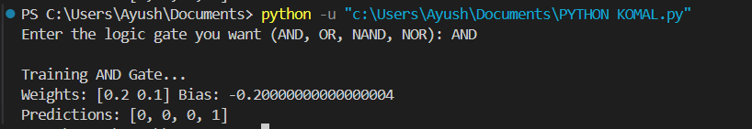

PRACTICAL :- 2
- Implementation of Backpropagation Learning Algorithm
Objective:
To implement and understand the working of the backpropagation learning algorithm in a multi-layer feedforward neural network.
Theory / Background:
Backpropagation is a supervised learning algorithm used for training artificial neural networks, particularly multi-layer perceptrons (MLPs). It uses the gradient descent technique to minimize the error by adjusting weights from the output layer back to the input layer.
Key Concepts:
- Forward Pass: Inputs are propagated forward to compute outputs.
- Backward Pass: Errors are propagated backward to adjust the weights.
- Loss Function: Typically mean squared error (MSE).
- Activation Function: Sigmoid is commonly used.
Software Requirements:
- MATLAB (Any version supporting script files)
- OR GNU Octave (for open-source users)
- MATLAB Editor and Command Window

Code:
from keras.layers import Dense
import numpy as np

# XOR input and output
X = np.array([[0,0], [0,1], [1,0], [1,1]])
Y = np.array([[0], [1], [1], [0]])

# Model
model = Sequential()
model.add(Dense(4, input_dim=2, activation='relu'))
model.add(Dense(1, activation='sigmoid'))

# Compile and Train
model.compile(loss='binary_crossentropy', optimizer='adam', metrics=['accuracy'])
model.fit(X, Y, epochs=1000, verbose=0)

# Test
print("\nXOR Output:")
print(model.predict(X).round())

OUTPUT:
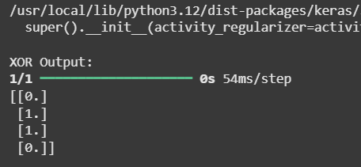

PRACTICAL :- 3
- Multilayer Feedforward Network using Backpropagation
Objective:
To implement a multilayer feedforward neural network (MLP) using backpropagation to solve the XOR problem, which a single-layer perceptron cannot handle.
Theory / Background:
- Feedforward NN: Data flows input → hidden → output.
- XOR problem: Not linearly separable; needs multiple layers + nonlinear activation.
- Backpropagation: Adjusts weights using error gradients (forward + backward pass).
- Activation functions: ReLU (hidden), Sigmoid (output) give non-linearity.
- Loss & Optimizer: Binary crossentropy + Adam for efficient learning.
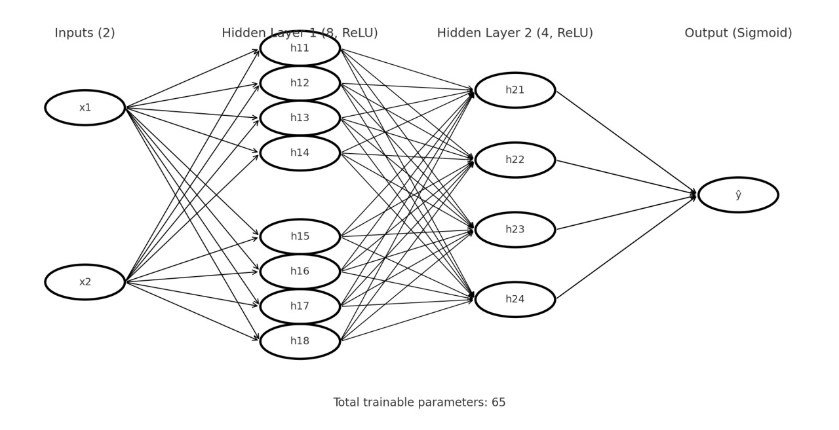
Key Concepts:
- Sequential model with stacked Dense layers.
- Hidden layers enable learning of non-linear patterns.
- Binary classification solved via sigmoid output.
- Training (fit) uses 1000 epochs → model learns XOR mapping.
- Prediction verifies learned outputs.
Software Requirements:
- MATLAB (Any version supporting script files)
- OR GNU Octave (for open-source users)
- MATLAB Editor and Command Window
Code:
model = Sequential()
model.add(Dense(8, input_dim=2, activation='relu'))
model.add(Dense(4, activation='relu'))
model.add(Dense(1, activation='sigmoid'))

model.compile(loss='binary_crossentropy', optimizer='adam', metrics=['accuracy'])
model.fit(X, Y, epochs=1000, verbose=0)

print("\nMultilayer Feedforward XOR Output:")
print(model.predict(X).round())

OUTPUT:
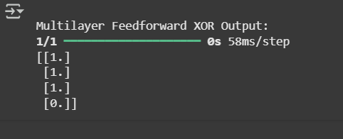

PRACTICAL :- 4
- Study of fuzzy inference system
Objective:
To study the concept and working of a Fuzzy Inference System (FIS) — understanding fuzzification, rule evaluation, and defuzzification using MATLAB’s Fuzzy Logic Toolbox.
Theory / Background:
- Fuzzy Logic:
A form of logic that handles the concept of partial truth — values between "completely true" and "completely false."
Unlike crisp logic (0 or 1), fuzzy logic works with degrees of truth (0–1).
- Fuzzy Inference System (FIS):
- A system that uses fuzzy set theory to map inputs → outputs through a set of IF–THEN rules.
- Main Components of FIS:
- Fuzzification: Converts crisp input values into fuzzy sets using membership functions.
- Rule Base: Collection of fuzzy IF–THEN rules.
- Inference Engine: Applies rules to derive fuzzy output sets.
- Defuzzification: Converts fuzzy output into a crisp numerical value.
- Types of FIS:
- Mamdani FIS: Commonly used; outputs are fuzzy sets that require defuzzification.
- Sugeno FIS: Outputs are crisp functions, often linear or constant.
Key Concepts:
- FIS is a framework for decision-making with imprecise data.
- Uses linguistic variables (e.g., "Low", "Medium", "High").
- Integrates fuzzification, inference, and defuzzification stages.
- Implemented easily using MATLAB’s Fuzzy Logic Toolbox.
- Mimics expert reasoning and approximate decision-making.
Software Requirements:
- MATLAB (Any version supporting script files)
- OR GNU Octave (for open-source users)
Code:
!pip install scikit-fuzzy
import numpy as np
import skfuzzy as fuzz
from skfuzzy import control as ctrl

temperature = ctrl.Antecedent(np.arange(0, 101, 1), 'temperature')
fan_speed = ctrl.Consequent(np.arange(0, 101, 1), 'fan_speed')

temperature['cold'] = fuzz.trimf(temperature.universe, [0, 0, 50])
temperature['hot'] = fuzz.trimf(temperature.universe, [30, 100, 100])
fan_speed['low'] = fuzz.trimf(fan_speed.universe, [0, 0, 50])
fan_speed['high'] = fuzz.trimf(fan_speed.universe, [30, 100, 100])

rule1 = ctrl.Rule(temperature['cold'], fan_speed['low'])
rule2 = ctrl.Rule(temperature['hot'], fan_speed['high'])

fan_ctrl = ctrl.ControlSystem([rule1, rule2])
fan = ctrl.ControlSystemSimulation(fan_ctrl)

fan.input['temperature'] = 70
fan.compute()

print(f"Fan Speed: {fan.output['fan_speed']}")
fan_speed.view(sim=fan)

Output:
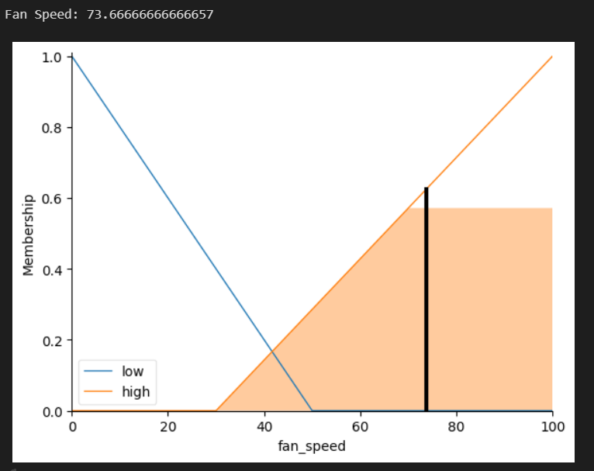

PRACTICAL :- 5
- To study fuzzy logic controller using fuzzy logic toolbox.
Objective:
To design and simulate a Fuzzy Logic Controller (FLC) using MATLAB’s Fuzzy Logic Toolbox for a simple control process.
Theory / Background:
- Fuzzy Logic Controller (FLC):
A controller that uses fuzzy logic instead of precise mathematical models. It relies on linguistic control rules and expert knowledge.
- Structure of FLC:
- Fuzzification: Converts input variables (error, change in error) to fuzzy values.
- Rule Base: Contains fuzzy IF–THEN rules describing system behavior.
- Inference Engine: Determines fuzzy control output.
- Defuzzification: Converts fuzzy output to crisp value.
- Example Rule:
IF Error is Positive AND Change of Error is Negative THEN Output is Medium.
Key Concepts:
- FLC provides smooth control for nonlinear and uncertain systems.
- Uses human-like rules for controlling dynamic processes.
- Does not require an exact mathematical model of the system.
- Combines fuzzification, rule evaluation, and defuzzification for control.
- MATLAB provides easy design via Fuzzy Logic Toolbox and Simulink blocks.
Software Requirements:
- MATLAB with Fuzzy Logic Toolbox
- Simulink(optional for simulation)
Code:
!pip install -q scikit-fuzzy

import numpy as np
import skfuzzy as fuzz
from skfuzzy import control as ctrl
import matplotlib.pyplot as plt

# Universes (0..100 with step 1)
x = np.arange(0, 101, 1)

# Inputs (Antecedents)
temperature = ctrl.Antecedent(x, 'temperature')
humidity = ctrl.Antecedent(x, 'humidity')

# Output (Consequent)
fan_speed = ctrl.Consequent(x, 'fan_speed')

# Temperature MFs
temperature['cold'] = fuzz.trimf(temperature.universe, [ 0, 0, 40])
temperature['warm'] = fuzz.trimf(temperature.universe, [20, 50, 80])
temperature['hot'] = fuzz.trimf(temperature.universe, [60,100,100])

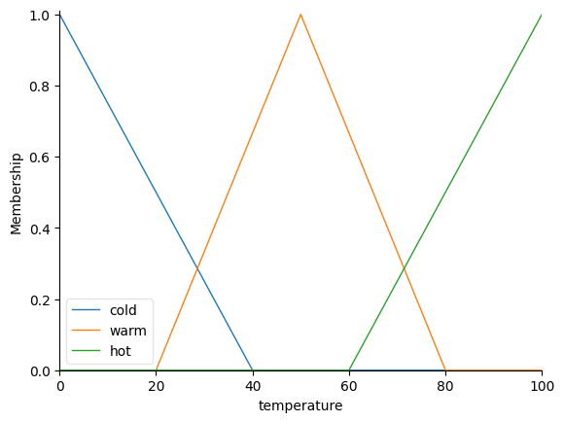

# Humidity MFs
humidity['dry'] = fuzz.trimf(humidity.universe, [ 0, 0, 40])
humidity['normal'] = fuzz.trimf(humidity.universe, [30, 50, 70])
humidity['humid'] = fuzz.trimf(humidity.universe, [60,100,100])

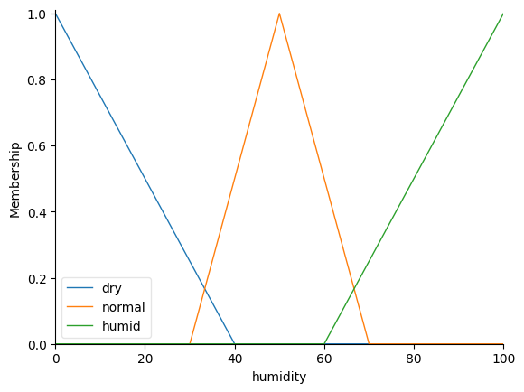
# Fan speed MFs
fan_speed['low'] = fuzz.trapmf(fan_speed.universe, [ 0, 0, 25, 45])
fan_speed['medium'] = fuzz.trimf(fan_speed.universe, [30, 50, 70])
fan_speed['high'] = fuzz.trapmf(fan_speed.universe, [60, 80,100,100])

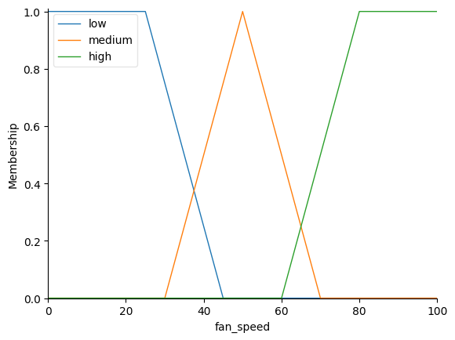

temperature.view(); humidity.view(); fan_speed.view();
plt.show()

rule1 = ctrl.Rule(temperature['cold'] & humidity['dry'], fan_speed['low'])
rule2 = ctrl.Rule(temperature['cold'] & humidity['normal'], fan_speed['low'])
rule3 = ctrl.Rule(temperature['cold'] & humidity['humid'], fan_speed['medium'])

rule4 = ctrl.Rule(temperature['warm'] & humidity['dry'], fan_speed['medium'])
rule5 = ctrl.Rule(temperature['warm'] & humidity['normal'], fan_speed['medium'])
rule6 = ctrl.Rule(temperature['warm'] & humidity['humid'], fan_speed['high'])

rule7 = ctrl.Rule(temperature['hot'] & humidity['dry'], fan_speed['medium'])
rule8 = ctrl.Rule(temperature['hot'] & humidity['normal'], fan_speed['high'])
rule9 = ctrl.Rule(temperature['hot'] & humidity['humid'], fan_speed['high'])

fan_ctrl = ctrl.ControlSystem([rule1, rule2, rule3, rule4, rule5, rule6, rule7, rule8, rule9])
fan_sim = ctrl.ControlSystemSimulation(fan_ctrl)

# Try an example input
fan_sim.input['temperature'] = 72
fan_sim.input['humidity'] = 65
fan_sim.compute()

print(f"Defuzzified fan speed: {fan_sim.output['fan_speed']:.2f}")
fan_speed.view(sim=fan_sim); plt.show()

Output:
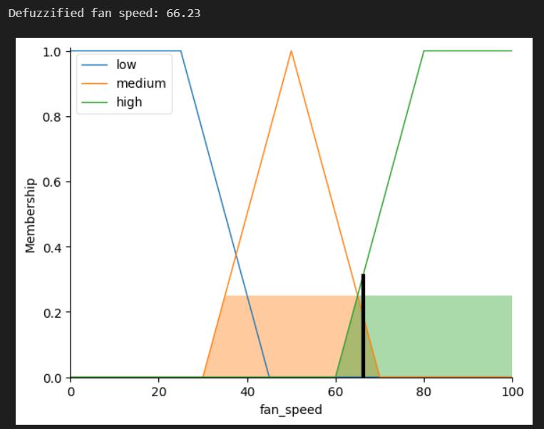

PRACTICAL :- 6
- To Study various defuzzification
Objective:
To study and compare different defuzzification methods used to obtain crisp output values from fuzzy results.
Theory / Background:
- Defuzzification:
Converts fuzzy output (a fuzzy set) into a single crisp value used for decision-making or control action.
- Common Defuzzification Techniques:
- Centroid (Center of Gravity):
Most popular method; gives balance point of area under curve.
y^*=(∫yμ(y)dy)/(∫μ(y)dy)
- Bisector:
Divides the output fuzzy area into two equal halves.
- Mean of Maximum (MOM):
Average of all maximum membership points.
- Smallest of Maximum (SOM):
Smallest value among maximum membership points.
- Largest of Maximum (LOM):
Largest value among maximum membership points.
Key Concepts:
- Defuzzification is the final stage of FIS.
- Determines crisp control action from fuzzy output.
- Different methods provide different crisp values depending on output shape.
- The Centroid method provides smooth and balanced results.
- Choice of defuzzification affects system accuracy and smoothness.
Software Requirements:
- MATLAB with Fuzzy Logic Toolbox
Code:
!pip install scikit-fuzzy --quiet

import numpy as np
import skfuzzy as fuzz
import matplotlib.pyplot as plt
# Universe of discourse
x = np.arange(0, 11, 1)

# Triangular membership function: trimf(x, [a, b, c])
mf = fuzz.trimf(x, [0, 5, 10])

plt.figure(figsize=(6,4))
plt.plot(x, mf, linewidth=2)
plt.title("Membership Function for Defuzzification")
plt.xlabel("x")
plt.ylabel("Membership Degree")
plt.grid(True)
plt.show()
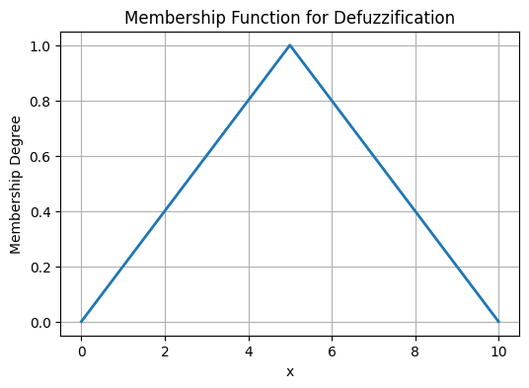
centroid = fuzz.defuzz(x, mf, 'centroid') # Center of Gravity
bisector = fuzz.defuzz(x, mf, 'bisector') # Vertical bisector of area
mom = fuzz.defuzz(x, mf, 'mom') # Mean of Maxima
som = fuzz.defuzz(x, mf, 'som') # Smallest Maxima
lom = fuzz.defuzz(x, mf, 'lom') # Largest Maxima

print("Centroid:", centroid)
print("Bisector:", bisector)
print("MOM:", mom)
print("SOM:", som)
print("LOM:", lom)

lt.figure(figsize=(10,6))
plt.plot(x, mf, label='Membership Function', linewidth=2)

# Plot all crisp defuzzified values
plt.axvline(centroid, color='red', linestyle='--', label=f'Centroid = {centroid:.2f}')
plt.axvline(bisector, color='green', linestyle='--', label=f'Bisector = {bisector:.2f}')
plt.axvline(mom, color='blue', linestyle=':', label=f'MOM = {mom:.2f}')
plt.axvline(som, color='purple', linestyle=':', label=f'SOM = {som:.2f}')
plt.axvline(lom, color='orange', linestyle=':', label=f'LOM = {lom:.2f}')

plt.title("Comparison of Defuzzification Techniques")
plt.xlabel("x")
plt.ylabel("Membership Degree")
plt.legend()
plt.grid(True)
plt.show()

Output:
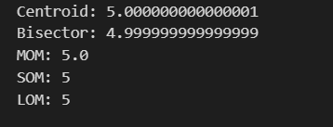
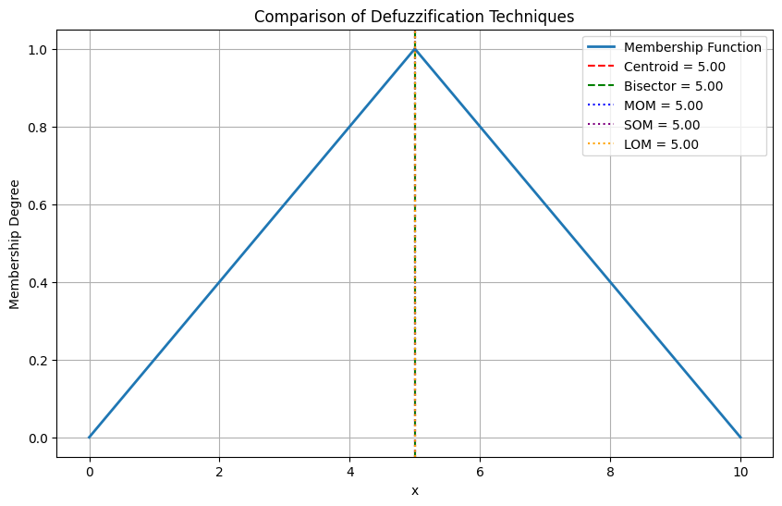
PRACTICAL :- 7
- To Write a program to implement of fuzzy set operation
Objective:
To implement and study basic fuzzy set operations such as Union, Intersection, and Complement using MATLAB.
Theory / Background:
- Fuzzy Set:
A set where each element has a degree of membership between 0 and 1.
- Operations on Fuzzy Sets:
- Union (OR):
μ_(A∪B) (x)=max⁡(μ_A (x),μ_B (x))
- Intersection (AND):
μ_(A∩B) (x)=min⁡(μ_A (x),μ_B (x))
- Complement (NOT):
μ_(A^' ) (x)=1-μ_A (x)
Key Concepts:
- Fuzzy operations generalize classical set theory.
- Union represents the maximum membership among sets.
- Intersection takes the minimum membership.
- Complement gives the degree of non-membership.
- MATLAB supports vectorized computation for these operations.
- Useful in designing fuzzy rule-based systems.
Software Requirements:
- MATLAB or GNU Octave
Code:
!pip install scikit-fuzzy --quiet

import numpy as np
import skfuzzy as fuzz
import matplotlib.pyplot as plt

x = np.arange(0, 11, 1)

A = fuzz.trimf(x, [0, 5, 10])
B = fuzz.trimf(x, [0, 3, 6])

union = np.fmax(A, B)
intersection = np.fmin(A, B)
complement_A = 1 - A

print("Union:", union)
print("Intersection:", intersection)
print("Complement of A:", complement_A)

plt.figure(figsize=(10,6))
plt.plot(x, A, label='A(x)', linewidth=2)
plt.plot(x, B, label='B(x)', linewidth=2)
plt.plot(x, union, label='A ∪ B', linestyle='--')
plt.plot(x, intersection, label='A ∩ B', linestyle='--')
plt.plot(x, complement_A, label="A'", linestyle=':')
plt.title("Fuzzy Set Operations")
plt.xlabel("x")
plt.ylabel("Membership Degree")
plt.legend()
plt.grid(True)
plt.show()

Output:
